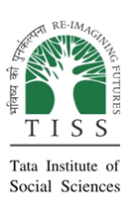
TATA INSTITUTE OF SOCIAL SCIENCES
Hyderabad
Experiential Learning- Group Report
Village Visited: Raghunathapuram
Mandal: Rajapet
District: Nalgonda
Group Number:- 3
Members - Surbhi(RDG) Shatakshi ( DS )
Renuka (RDG) Riya (DS)
Dibyendu(RDG) Sumit (DS)
Debolina(DS) Vishnu (DS)

TABLE OF CONTENTS
PAGE NUMBER | TITLE
2 | Introduction
2 | Objectives
2 | Methodology
3 | Village Profile
4 | Resource Map
4 | Religion
5 | Women’s Representation
6 | Schemes in Ragunathapuram
8 | Livelihoods
17 | Governance
18o | Social Structure
20 | Self Help Groups
22 | Education
26 | Health
30 | Reflections
32 | Suggestions
32 | Suggestions

INTRODUCTION

“India is not Calcutta and Bombay; India lives in her seven hundred thousand villages.”
- M.K. Gandhi

In light of the above statement, Gandhi reflects on the understanding that more than 50 percent of the Indian economy lies under agriculture which is not situated in the concrete world but rather villages. These providers of food and basic things enable entire India with sophisticated technology to sustain further on and when policies related to these ‘roots of India’ are made by bureaucrats at distant offices it not only impacts them but also the entire Indian population, thus it becomes inevitable to understand these villagers.
To accomplish the same students were given opportunities by TISS and Palle Srujana to visit the village and explore the grassroots realities.

Understanding of villagers can’t be seen in isolation from various other aspects of livelihood, economy, culture, and creeds, etc and so laying objectives for the same is of prime importance.

OBJECTIVES

The objective of understanding villagers was completed by understanding the livelihood, economy, governance, social structure, health, and education aspects. Light upon each area is reflected in the following sections.
Before looking on the mentioned section it is important to explain the tools used.

METHODOLOGY

When any objective has to be achieved it has to be backed by some methods to make them more efficient and thus, interview, focussed group discussion, and observation-based understanding was used by the group to achieve the same.
The group proceeded with interviewing the villagers, observing their activities, social behaviour, apparent realities culminating into a focussed group discussion with various groups such as Self Help Groups, Padmashali community, officials of the gram panchayat etc.
Using these tools group tried to collect data and understand the above-mentioned objectives as detailed below.

VILLAGE PROFILE

Village | Raghunathapuram
Mandal | Rajapet
District | Nalgonda
Total population | 4008
Male | 2048
Female | 1960
Sex Ratio | 957:1000
Literacy Rate | 72.04%
Male Literacy Rate | 84.39%
Female Literacy Rate | 59.08%
Communities | Padmashali,Rajaka,Goud,Mudhiraj,Mangalvalu,Mala,Madiga,Komati,Reddy,Balige
No. of Anganwadi Centre | 4
No. of SHG | 84
No. of Primary school (up to fifth class) | 1
No. of Secondary school (up to tenth standard) | 1

RESOURCE MAP OF RAGHUNATHAPURAM

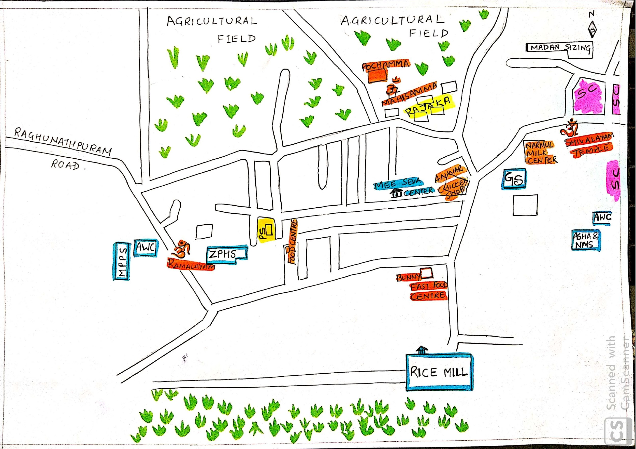

RELIGION

The first look of the village map gives us an explicit idea that there is hardly any Muslim and Christian communities noticed due to the absence of any mosque and church, and same was reflected in the study also as there were only 3 families of Muslim and no Christian family’s presence was witnessed, leaving Hindu religion to be pervasive in the entire village. Various traditional cults and creeds of Hindu religion were practiced by the villagers whose evidence were visible such as worship of ‘Illama’(dunes made by termites are worshiped as God), community meeting of Padmashali community only on Amavasya day. Worship of Illama gives a good idea of preservation of biodiversity and community meet taking off from work signifies towards the ‘we feeling’ among the community.
Talking about the intermingling of the two religions- Muslim and Hindu, the group observed that Muslim families are just taking part in the economy and not politics and other aspects of the village. This was confirmed by interviewing Mr. Md. Anwar.

Case study - Md. Anwar

He is an owner of a chicken shop at this village who migrated four years back to enhance the business opportunities and presently live in a rented house. He also said that his community does not feel isolated albeit being a minority. In order to perform his Friday prayers, he goes to a nearby village Aler(10 km from Raghunathapuram). His family and one other Muslim family’s economic activities are based only on the chicken shop while one Muslim family also owns agricultural land to work upon.

Interviewing Anwar gives an idea about economic well being of the village, migration from other villages to this village, and intermingling of religion only based on economic aspect nothing else.

However, segregation in terms of religion is hard to determine due to less number of muslim families in the village but the same also raises the question of why less number of muslims families reside here when nearby villages have them in large numbers. This segregation is evident also when intra-regional aspects are seen as people of Rajaka community(who wash clothes) have their separate temples- Maisamma and Pochamma temple to worship as they are not allowed to worship in temples of other BC castes. Kavita, one of the members of Rajaka community, said that while talking to us said that people of other community say “ye chote log kya pooja karege”.

WOMEN’S REPRESENTATION

Case study - Rajaka Community- Kavita

- Kavita, a member of Rajaka community, came to the village after her marriage at the age of 16 and has been living here for the last 15 years.
- Institutionalisation of Caste- She was able to speak english and hindi due to her education in hyderabad city as father was working in FCI(D grade jobs), but still she regarded washing clothes of other community and the cleaning of dead bodies and other works as her role.
- Kavita - “this is our role to wash cloths and do cleaning work of dead bodies”
- Kavita - “Agar hum dusri community ka kam karege to fine padega 5000 rs ka”
- Women are mere faces in politics - kavita said that use of money which they get from SHGs are decided by their husbands.

Looking at the voter’s list we get an idea that 49% of the population is female.
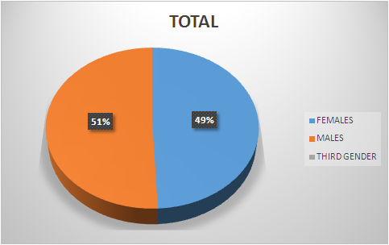
(source - gram panchayat voters list)

In the village Gram Panchayat, all norms relating to women’s reservation are followed theoretically - 50% women ward members (6/12) and a female MPTC. Elected women representatives were for mere face value, male members(especially husband) of their family take part in all gram sabha meetings including those involving policy votes. B. RENUKA MPTC member was represented by her husband in every meeting, same was confirmed by VRO. Even the SHG loans taken by women are then handed over to men who have a final say in its utilisation(confirmed by members of SHGs). However, women do play key roles in all major occupations of the village and had a voice in the home, which our group observed on our visit to some houses. The idea of domestic violence exists, but no conversation exists around it.(Kavita - “paise nhi denge to marega varna kyun marega, or hum iske bare me bat nhi karte ”).

SCHEMES IN RAGUNATHAPURAM

Actively visible central and state government schemes in the Raghunathapuram

Central Government schemes | State Government schemes
1.PM KISAN MAAN DAAN YOJANA | 1.RYTHU BANDHU& RYTHU BHIMA
2.SWACH BHARAT ABHIYAN GRAMIN | 2.BAGIRATHA & KAKATIYA MISSION
3.MGNREGA (WEEDING , CHECKING DAMS,LAND LEVELLING) | 3.HARITHA HARAM & KANTI VELUGU
4.MUDRASCHEME(ONLY 150 WEAVER HOUSEHOLDS) | 4. 30 DAYS PLAN
 | 5.ASSARA PENSION & KALYANA LAKSHMI
 | 6. KCR KIT

Impact of the schemes:
According to our observation, mainly many state government schemes were implemented in the village very efficiently and very less percentage of central government schemes implementation is noticed seen by the absence of Pradhan Mantri Fasal Bima Yojana (crop insurance), Ayushman bharat and many people awaiting for Mudra scheme benefits etc. So though state government is implementing many schemes in the village but efficiency and feedback of the scheme implementation was neglected. For example, through Bhagiratha mission, water got supplied to all houses every day, but the water was noticed often had a yellowish colour; and also under Swachh Bharat Mission many toilets were built but water connections were not given. So, there must be clear surveillance of schemes which are already in implementation and also different other beneficiary schemes must be at the doorstep of the village .

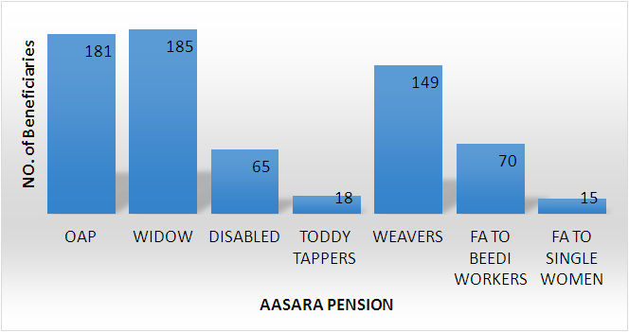

LIVELIHOOD

“A livelihood comprises people,their capabilities and their means of living,including food,income and assets.A livelihood is environmentally sustainable when it maintains or enhances the local and global assets on which livelihoods depend, and has a net beneficial effects on their livelihoods”(Chambers)

DIVERSIFICATION

Livelihood diversification is defined as the process by which rural families construct a diverse portfolio of activities and social support capabilities in order to survive and to improve their standards of living.
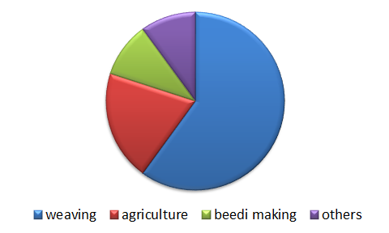
Fig : Livelihood Portfolio of Raghunathapuram Village

NON FARM ACTIVITIES

Non Farm activities play an important role in rural areas. As per the tenth agricultural census, the average size of agriculture landholding declined to 1.08 hectare in 2015-16 from 1.15 hectare in 2010-11. Hence, reducing the dependency of rural masses on agriculture as a source of income will help in improving the overall income of rural population. Non farm activities are gaining prominent importance in rural areas due to various reasons such as:
- Prevents Migration
- Requires less capital
- Increases the income and also supplements the agricultural income
- Provides means to farmers to cope with farming distress
- Potential to generate employment opportunities

NON-FARM ACTIVITIES IN RAGHUNATHAPURAM
The main occupation of majority of people in Raghunathapuram is weaving, which is a non farm activity. The economy of the village depends on weaving as nearly 60% of the population (Padmashali Community) in Raghunathapuram follow weaving as their main livelihood. And most of the remaining population is directly or indirectly involved in weaving.
Other than Weaving, there are many non farm activities that we observed in Raghunathapuram which are as follows:
Beedi making:
Most of the beedi makers were women, thus it seemed like a gender specific activity (eye witness). They get 150 rupees on making 1000 beedis; tendu leaves and tobacco power as raw material are provided by the contractors and even threads are provides. Beedi making is enabling women to make money in their free time.
Transportation:
Transportation is another non farm activity which is enabling farmers to transport their products to nearby markets (1200 for one trip), and also providing other transportation services.
Barber Shops:
There are 4 barber shops in Raghunathapuram. The barber we met during our study manages to earn 200 rupees( 50/--60/- from each customer) daily. And he pays 300/- per month as land rent. The rent they are paying is relatively cheaper compared to that of cities. And the most important thing is that they are not facing any competition even though there are many salons in nearby towns.
Retail Shops:
There are nearly 10-15 retail shops in Raghunathapuram. The most sold items were groceries like rice,dal and sugar. They manage to do business of 3000-4000 daily.They buy all the items required for shops in Aler, Bhongir and Hyderabad.
Medical Shop:
There is one medical shop available in Raghunathapuram. The most sold medicines are body pain tablets as most of the people belong to weaving community and followed by farming they are mostly suffering from body pains. This shop owner manages to do business of nearly 7000/- rupees.

Street Food Sellers:
There is one panipuri(street food) stall and a hotel( in house)in Raghunathapuram. They don’t pay any rent for the place.Daily business is nearly 1000/- - 2000/-. Business hours are from 7:00 to 10:30 in the morning and 5:00 to 8:00 in the evening.
Chicken Shops:
There are 3 chicken shops in Raghunathapuram which are owned and managed by muslim community.They get hens from Suguna poultry and Sneha Poultry.There are no business relations exists.Daily business is between 2000/- - 3000/- rupees.
Cosmetic Shop:
There is one cosmetic shop in Raghunathapuram to which most of the customers are school going girls and teenagers.This shop runs successfully only during festival seasons and during marriages. This shop is owned by a woman.
Pottery:
There are only few families following occupation as there is no mud available near lakes and mostly nowadays people are buying pots only during summers and during festivals like Bonalu and Ugadi.
Women Participation in Non Farm Activities:
It is interesting to note that women are comparatively more in non farm activities than men in Raghunathapuram. Even though this participation made women to earn on their own still most of the women in Raghunathapuram don’t have financial independence or any say in their families and in their village.

WEAVING
The rural economy has been predominantly dominated by agriculture sector, where the mainstay of people is agriculture. Interestingly in Raghunathapuram, rural economy was dominated by non farm activities most specifically weaving. More than 60% of the population of the village practiced weaving and the associated work. They manufactured different products like Sarees, Ugandan Dress, Dress Material, Lungi, Towel, Handkerchief etc. Majority of our respondents used handloom, few of them even use power looms as well. Raw material which is yarn here ,was imported from two places for manufacturing different products. Yarn for sarees and dress material was imported from Coimbatore where as yarn for weaving lungi, towel and handkerchief was imported from Pakistan.(source :Madan Sizing Company)

Initially we thought that each and every weaver we came across, was an entrepreneur. But, gradually in our interactions with the weavers, we discovered that they all are working on wages. There were in total 4-5 master weavers referred to as seths by the weavers, who were controlling the entire weaving work in the village. They provided yarns as well as designs and later collected the finished product from them. In return these master weavers provided them wages which varied from Rs.40 per piece to Rs.2000 per piece depending upon the product that they weaved. (Table 1.1)
Name of the Respondent | Family Size | Job Role | Product | Wages
K.Shankar | 5 | Weaver | Ugandan dress | Rs. 40 per piece  Total piece in a month - around 200  Total Income =8000- 10,000
K. Shankar | 2 | Weaver | Cotton Saree | Rs. 600-700 per piece  Total Piece in a month - 10 -14 sarees  Total income = 7000-10,000
K.Ramesh | 6 | Weaver | Silk Saree | Rs. 1500- 2000 per piece  Total piece in a month - 8  Total income = 12000-16000
Table 1.1 Wages of the respondents

Table 1.1 depicts that the wages were not sufficient to meet even the basic necessities of life. Considering the labour intensive nature of the job, most of our respondents ( both young and old) complained about the problems of back pain,asthma and headache. As a result of which, a substantial part of their earnings were spent on healthcare. This leaves them with less money for savings and for doing other household work.

Challenges Concerning Weaver’s Community

Besides, health issues, other major challenges that the weavers mentioned were:
- Heavy dependence on master weaver for everything- yarn, credit etc.
- Lack of interest among the young generation to sustain the sector in the wake of being less remunerative.
- One of the most important concerns highlighted by the female students (Class VII - Xth), was that they don’t want to continue weaving because their parents are not respected and are not treated with dignity.
- Modern technology-- rampant use of powerlooms to meet the rising demand in the market is severely impacting the handloom users.

Coping Strategy
Therefore, to cope with such challenges, weavers on one hand, have diversified their livelihood portfolios. Besides, weaving, their other source of incomes are Beedi making, retail shops, renting Vehicles, farm labourers etc.
On the other hand, to cope with the competition and a slump in demand of the products, Merchants ( master weavers) have mentioned that since they have been in the business past 40 years, so they can handle the slump with ease.

Importance of weaving in the village
In the interaction with the weavers, we found that weaving holds a great significance among the people of Raghunathapuram. They mentioned to us that, because the weaving provided jobs to people throughout the year, people prefer to stay back in the village during lean seasons. And also, it has been significant in promoting ‘reverse migration’. Respondents have told us that people who migrated to nearby areas in search of better livelihood opportunities, are now coming back to the village. This is primarily because weaving sector gives job to them and they are able to earn the same amount which they have been earning at another place.
Labour specialization has been instrumental in sustaining the sector. Respondents have pointed out the weaving work is distributed among the villagers. For Instance, If some weavers are making the bed sheets then some weavers will tie knots where as some will add a border on it. Thus, everyone had work in the village , demonstrating the importance of weaving sector for the village and its economy.

Significance of Amavasya for weavers:
On the day of Amavasya,all the looms are shut. There is a belief that if weavers will do any work on amavasya,some evil will surround them. So,instead, they prefer to meet under ‘Meeting of Weavers’ at their community hall.
The meeting is chaired by the President joined by the treasurer. In the meeting, problems of the weavers are heard and addressed.

Other Observations on Weavers :
- Appeared to be content and proud of their work
- Valued education - showed keen interest in their children’s higher education
- Enthusiastic Old people - discussed with us about their work, their problems and their work in great length with us.They have mentioned to us that after the age of 50 years, they receive Old Age Pension of Rs.2000, which they consider a major relief as it helps them in tackling old age problems.
- Awareness level is commendable. They were aware of where their product will be exported to. For Instance, one weaver, taught us how to wear Ugandan dress, which he was making.
- In every two years, wages of the weavers are reviewed.

Innovation used by the community-- ASU MACHINE :

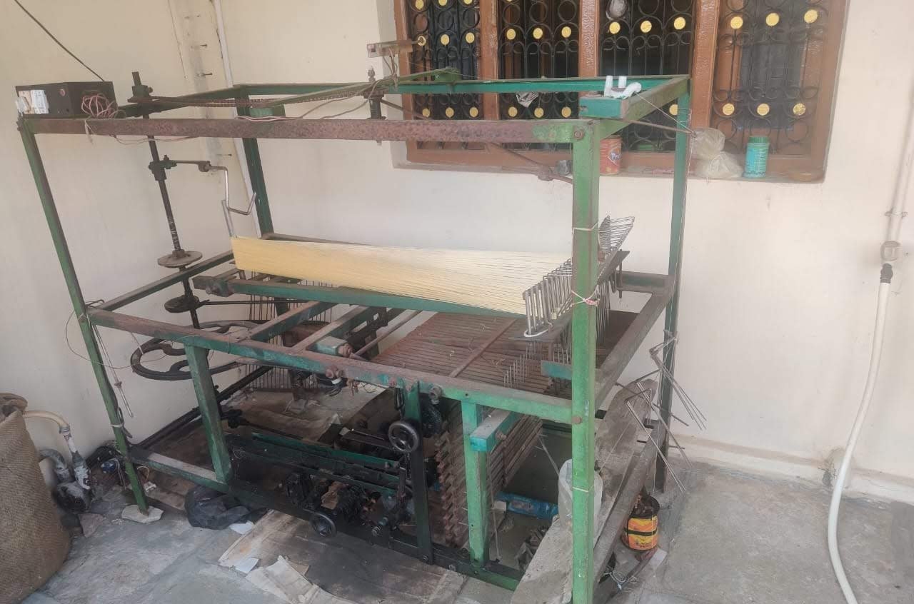  Fig(a): Asu Machine | Asu Machine (fig a), was designed by Mallesham ( Padma Shri Awardee), for his mother in an attempt to reduce her shoulder pain and also to reduce her labour time. This machine is used for making Pochampally Silk Sarees. This requires 9000 rounds. Therefore, the machine has made the job of the weavers easy. It reduced the weaving time from 6hours to 1.5hours. In Raghunathapuram, presently it was used by 10 households. Of which, we got the
chance to meet with few weavers. When asked on why other weavers are not using this. Their reply brought the question of affordability in light. They said that since it costs around Rs. 25000, so most of the weavers cannot afford to buy.

FARM ACTIVITIES IN RAGHUNATHAPURAM:
In Raghunathapuram village only thirty percent villagers practiced agriculture as major occupation (as per sarpanch), but whatever they produced was sufficient for the villagers regarding food crops and the village was a very good producer of cotton. Apart from crop cultivation in farming sector, other activities were dairy, poultry, toddy topper and goat rearing. There was no vegetable cultivation in the village. For vegetables villagers were dependent on “Sunday Market” which was held in the particular village where people from neighbouring villages sold vegetables.

Agriculture:
Any livelihood comprises of three major components- assets, capabilities and activities.
- Assets: There are five types of assets-
ASSETS
Natural
Physical
Human
Financial
Social
- Natural Assets: land (villagers had on an average two to eight acres of land. Very few villagers were there who belonged to Goud and Reddy community held twenty acres of land. The land contained red loamy laterite soil which is good for cotton cultivation and the village itself was also good producer of cotton), small pond (few farmers had constructed small pond just beside the field. During the rainy season only, those ponds were source of irrigation).
- Physical Assets: tractor (there were six tractors in the village which were used for ploughing and it charged Rs. 800- 1000 per hour), bore well (this was the only permanent source of irrigation and for this authority did not demand any electricity charges but Rs. 1 per day customer charge was there), different implements like sprayer, spade, grass cutter were also available, motor van (there were four motor vans in the village which were used to transport cotton to the market and the van owner cum drivers charged Rs. 1200 per 10 km for full loaded van).
- Human Assets: Farmers, Agricultural Labourers (their wages were Rs. 250 per day).
- Financial Assets: Farmers were financially supported by the government with different schemes like Rythu Bandhu, Rythu Bima, Pradhan Mantri Kisan Nidhi Samman etc. They were not accustomed to bank accessibility. They usually depended on private money lenders (who belonged to vaishya community) at the interest rate of two percent per month.
- Social Assets: They were familiar with some people who indirectly supported them in their activities like owner of paddy harvester (who belonged to Yadagirigutta) provided his machine with the charge of Rs. 2500 per hour but the condition was menium ten acres of land would be there for harvesting, some people who provided tarpaulin of 15ft×15ft at the rent of Rs. 20 per piece per day, shopkeepers of fertilizers and pesticides who recommended the pesticides by seeing the pest or disease infested leaf.

- Capabilities: Farmers were sufficiently skilled and they had the right of land. Regarding irrigation in summer season they had to supply water from beside villages because Gandamala irrigation project was still not implemented in the village.

- Activities: All activities regarding cultivation of cotton (bollgard Ⅱ was the cultivated variety), paddy (cultivated varieties were sona masuri, telengana sona, BPT, warangal 14 etc.), jowar, maize, pigeon pea and marketing of cotton to the government institution with MSP (other crops were cultivated for home consumption and local sale).

- Challenges: scarcity of water during summer months was a major problem, poor yield during the period of natural disasters, crop insurance scheme was still not implemented, there was no soil health card of any farmers and hence they applied inorganic fertilizers by their own and fertility of soil was decreasing gradually.

- How they cope up: following diversification. They practiced seasonal migration to Hyderabad and other places for labourer work during growing period of crop when work was less and the most preferable solution was dairy which they practiced significantly and beside every field farmers had a cattle-shed.

Dairy:
- Reared Cattle: cow (reared breeds were indigenous breed and jersey. One progressive farmer was rearing HF breed which gives around 17-20 litres of milk per day whereas indigenous breeds and jersey give 2-3 and 6-7 litres of milk respectively. Very few farmers reared buffalos. Though the price of the buffalo milk was higher (as price was fixed according to the concentration of milk), farmers did not prefer to rear buffalo because buffalos are more susceptible to disease and it stops milking earlier than cow (only after 1-2 years of calving).
- Cattle feed: Dhanna(artificial feed), Green Grass, Paddy straw, Subabul fruit, Oil Cakes of cotton, rice, groundnut. All items were important. According to the farmers if any of the mentioned item was not provided then milk production would be drastically reduced. In case of HF cows during uneven rainy season due to unavailability of green grass milk production was reduced to 6 litres only.
- Common disease: Cattle animals of that village were susceptible to uterus related diseases. For treatment one veterinary doctor was there but he hardly came to the cattle shed. One compounder handled the matters.
- Breeding of cattle: Villagers were fond of artificial insemination for breeding of their cattle animals instead of indigenous process of breeding.
- Marketing of the produce: There were two milk collection centre- NARMUL milk (government) and Sri Venkateshwar milk (private). Villagers preferred to sell milk to the private milk collection centre because there was a provision if a farmer sold milk to the NARMUL then they would receive Rs. 4 per litre of milk, but this never happened. Even cow dung was also sold at the price of Rs. 1200 per tractor but farmers used cow dung during field preparation.
- Facilities provided by government: Government provided subsidies on cow of 70% for SC and ST and 50% for BC community. They also provided insurance at the premium of Rs. 2000 per year.

Rice Processing Unit :
There was a rice mill which belonged to the neighbouring village of Raghunathapuram but the mill owner belonged the village only. There were two steps. Unpolished rice were produced from paddy in first step and in second step polished rice was produced. During the first step produced byproduct was rice husk and during second step brown rice bran, white rice bran and nukalu were produced. Rice husk was sold to the beer and brick industries. Brown rice bran and white rice bran were used as cattle feed and poultry feed respectively. Farmers who used to come to mill for processing their paddy they had to pay no charge if they did not demand the byproducts, otherwise they had to pay Rs. 20 per kg of paddy.

Women’s Participation in farming sector:
Women had equal participation regarding the time investment but input and output marketing, taking decisions were handled by the men. There was wage gap also between men and women labourers. When we visited the mill we have seen there were one male (supervisor) and two female worker and according to the supervisor the wage of supervisor was Rs. 10000 per month whereas women workers were paid with Rs. 5000. (one reason was also there that supervisor was more skilled than women workers).

GOVERNANCE
The trickle-down effect of amendment done in 1992 (73rd amendment) was explicitly visible in the form of gram panchayat and local village politics.
The gram panchayat in Raghunathapuram village was headed by the Sarpanch, followed by vice sarpanch, MPTC (Mandal Parishad territorial committee member), as well as 12 ward members. Sarpanch and MPTC were only posts that got the salary from the state government. Rest of the members including the vice sarpanch and 12 ward members were of voluntary nature. This voluntary service provides an idea of a robust democracy and political structure in the village at least theoretically if not practically. The practical nature of the same becomes skeptical because 12 ward members’ recommendations were only of advisory nature who were acting as toothless tigers. The source of this information was the interview of ward members - Mr. K.karunakar(1st ward representative) and Mr. Bhashkar(12th ward representative).
The seeping of decentralization could also be seen as village panchayat was collecting their own taxes such as water tax and property tax apart from the 1,60,112 rupees allocated annually from the 14th finance commission.
Water tax charged was 50 rupees per month and house tax charged was 300 - 3000 rupees depending on the structure of the house, the money collected through taxes was utilized to pay the salaries of people working in the gram panchayat for example field assistant, waterman etc. Raju who was the supervisor of field assistant, waterman etc was one among the person receiving a salary from the same.
The governance structure was handled by interplay of various political parties. There were four dominant political parties - Indian National Congress, Telangana Rashtriya Samiti, Telugu Desam Party, Bharatiya Janata Party and at present Telangana Rashtra Samiti was in power. There was also evidence of CPI party as the group encountered a man named Rajesh comrade which signifies his membership with the CPI party and the same was confirmed by the man but presently this was obsolete.

SOCIAL STRUCTURE - CASTE BASED WORKS & HIERARCHIES

In India, our historical pattern reflects how society is stratified on the basis of caste and the occupation of an individual is determined by his birth and the caste of their birth. Since from the past every caste group is involved in their own occupation, they attained perfection in their own skills, but on the other hand, due to the caste-based works, there is a rise in socio-economic disparities in society. In changing periods through time, diversification of work took place by many individuals breaking out from caste-based works to enhance themselves to the different fields of work. Our study mainly reflects how villagers of Raghunathapuram pursue caste and its occupations according to their own understanding and how their livelihood revolves around caste and finally pointing out the caste inequalities situated in the village.

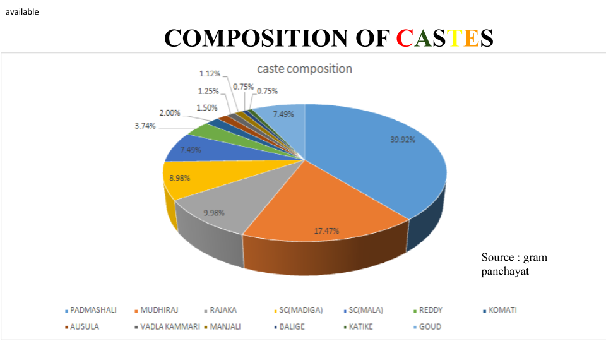

Above graph defines the composition of different castes in the village . The Padmashali community (OBC) and Mudhiraj (OBC) form the bulk of the population, Rajaka’s and other backward caste people are less in number. This is followed by scheduled caste population (Mala and Madiga ) and lastly very less percentage of upper caste people(Reddy and Komati) lives in the village .

In Raghunathapuram, the dominant castes were Padmashali and other OBC communities. These castes live together and there are different colonies for scheduled castes according to the land allocation taken place by government decades ago. Out of 900 households, 600 households belong to the weaver community. Socio-economic status of each weaver is different based on their work and assets . Even people from other castes in the village strict follow the caste based works without any resistance as there was institutionalization of caste where everyone took their work as a role and did not see it as exploitation .

Caste segregation was clearly observed by viewing different sanghams (community halls); with many caste groups having their own sangham halls to discuss their own caste’s problems. Hence, no village community hall existed, only those formed on community lines.
Same is seen with respect to cults and creeds; for example Bathukamma festival is first done by the dominant communities and then followed by the other communities such as SC, Rajaka, etc. No assimilation of all castes is seen. On the other hand, despite the Reddy’s caste group who holds huge land, Goud caste group people also have huge farming lands. So the explicit power is controlled by the Padmashali community but the implicit power is controlled by the Goud’s community due to their high economic status and their dominance which is clearly evident at times of grama sabha and crucial decisions apart from the officials of gram panchayat in the village .

Case study - K. Karunakar- 12th Ward member

He is one of the ward members: 32 years old, graduate, belongs to the SC community. He is the sole representative of SC community. He said that their advice was mere recommendation and the final say belongs to the Sarpanch and Vice Sarpanch who belonged to the Padmashali and Goud community respectively. He also stated that in his 32 years of living, only last time SC candidate became Sarpanch.
We further witnessed a fight among ward members regarding facilities like many ward members demanding for sharing equal resources like water problems in sc colonies which is not seen other colonies in village. He also said that the SC community is completely separated from other communities. This is also evident from the resource map presented above.

FOCUSED GROUP DISCUSSIONS – SELF HELP GROUPS
Self Help Groups (SHGs) are formed by women usually consisting of 15 to 20 members. In Raghunathapuram Village, SHGs are formed either on the basis of a particular community or with the heterogeneity of communities with a total of either 8, 10 or 12 members in each group. At present, total 84 SHGs have been formed in that village. We have done our focused group discussion with one SHG Group where all members belonged to the Padmashali community.
They stated that, every meeting must be started with their SHG Anthem which basically translated to mean that if they will work together and help each other in the fulfillment of their needs then they can bring heaven down on earth. As they come from their homes with different perceptions, so it helps them to concentrate on their work as a group. Our meeting was also initiated with the SHG Anthem after which we started with our discussion.
Management of their passbook :
Their pass book is linked with the Central Bank of India and Stree Nidhi Bank, where they save some amount and can apply for loans as well. They can also get two loans at the same time by applying in the respective banks. Principal loan amount is divided equally among the group members or sometimes it divides only among 3 or 4 members depend on the requirements. 100Rs and 10Rs are the minimum savings amount that they save in Central Bank of India and Stree Nidhi Bank respectively.
Recently, that particular group has taken a loan of Rs. 5,00,000 with interest rate of 12% a year and minimum repayment time period of which is 2 years; where the amount was divided equally among the group members, that is, Rs 50,000 each, consisting of 10 members. If the payment is delayed and paid after the date then Rs. 100 shall be charged with every passing day. And, they can also extend the repayment period of the total loan amount for up to 4 or 5 months.
Any group member can share her portion of the loan to other members depending on their requirements but that member has to pay interest on her loan as well as on the amount she has taken from the other members. On the question of SHG formation, majority of the respondents came up with similar answers that taking loan in group helps them to get the loan easily comprising of higher amount, not a time taking process and also no need of collateral as bank requires. Education, Marriage, Health issues, cattle and weaving machines were the major reasons behind taking loans.
They conduct financial meeting, health meeting and also General Body Meeting is conducted by Assistance Project manager and Cluster Coordinator once in every month where leader of all the groups come up with and address different kinds of issues.
Case Study with SHGs Convener
SHGs Convener can also be called as Village Book Keeper. In that village, there are a total of 3 VBKs, where each VBK controls around 30 SHG groups. We met with one SHGs Convener Vitta Srinivasam. His role is accounting and motivating women for loan purposes and he is also a bank correspondent with a salary of 4000. He also had a weaving machine and his wife made beedis and earns around 3000 a month. He said that his sign is must from before taking loans. And only village residents can be a part of SHG Group.
He mentioned that they get training from Society for Elimination of Rural Poverty (SERP). And age group of 18 – 60 years can be a member of SHG group. According to his opinion, majority of the women handover their loan amount to their husband to use in their occupation as according to them, men are the head of the family.

EDUCATION SECTOR
Raghunathapuram marked an overall literacy rate of 72.04% which is higher than the state average combining both Andhra Pradesh and Telangana; with total male literacy about 84.39% and female literacy rate about 59.08% respectively according to census 2011. Through our visit to schools and interviews with students and teachers, we noted that maximum of the students were from Padmashali community,the major weaving community; and maximum of the villagers were Xth passed most often from the same higher secondary school.

Coming to the educational institutions:
- Anganwadi centres:
In Raghunathapuram there are a total of 4 Anganwadi centres and under one centre comes thousand population; here one teacher and one servant with qualification of Xth and XIIth pass including training is present. Children of age group 3 to 4 years are taken care of in these centres, inspection maintained in every two or three months, even mothers and pregnant women are given care, nutritious food, health awareness and education.
Under the Rashtriya Bal Swasthya Karyakram (RBSK) the four Ds (defects of birth, disabilities, deficiencies, diseases and development delays including disabilities) are looked after. This is supplemented with regular health report measurement of both height and weight. The rest three anganwadi functions similarly and each community of the village have its own anganwadi center with population divided equally under them.
- Primary School
Total number of students are 205 with age group 5 to 7 years with total 5 teachers respectively. The headmaster provided donation of about Rs.50000 to Rs.60000 for the school he even had organised plantation programmes. The primary school has its own small library with teaching up to Vth standard with regular ptm meetings and mid-day meal.
Under this comes Vidhya Volunteers for the primary school, their monthly salary is Rs.12,000 and their position is not permanent until the govt. recruits another teacher. Telangana govt. has engaged total 18,78 Vidhya volunteers in govt. schools across the state for the academic year 2019-2020.
- Higher Secondary Education in the village
Total number of students are 375 with total staff 19 including both teachers and workers with 30 students under one teacher; the teachers were not from the village itself but rather travel from the cities (as mentioned by the one teacher we meet during the visit). The Zila Parishad Higher Secondary School had 90% attendance with zero dropouts. It had approximately 200 girls and three toilets out of which only one was currently in use.
According to the student review they are provided with mid-day meal but its not sufficient and not satisfactory for them. The school was English medium with only one section of class Tenth in Telugu medium.
Here 60 days plan had also been included under which the students were provided with clean drinking water under Mission Bhagiratha. Even Medha Scholarship Test been conducted which if passed, the student would be provided with financial aid for their higher studies (even their stay would also be taken care) after class tenth. Sahaja Foundation has been included under the list of donations the school gets; here also voluntarily donations and Mr. Reddy been mentioned who has donated around 50 cycles for the students including the village people also contribute, personal necessary items kit has been provided , also conduct monthly once ANM health check-up and doctor check-up once or twice in a year. The school curriculum also include digital class after completion of each chapter.
Case Study : Student’s review of the School and the village
During our visit in the village Raghunathapuram higher secondary school we conducted a small activity where we have collected reviews of the students from class VIth to Xth class, the likes, dislikes their suggestions about their village was really illuminating.

Table 1.2 Response of the students about their village:
Positive response of the students: | Negative response of the students
- The village people have good human relations, have proper education facilities, the village people are really hard working, they have a responsible gram panchayat with all basic necessities, even their village is clean and green with proper drainage facilities. | - They have a lack of medicines, have no hospitals nearby, no college, not that convenient transport facilities with only two bus, they even don’t have proper ownership of their house.
- The climate is good enough with presence of markets, water facilities with transport system and street lights. | - They have lack of govt. schemes, improper sanitation with no proper garbage disposal, presence of street dogs and pigs and spread of dengue was also mentioned.

Table 1.3 Response of the students about the working of their school:
Positive response | Negative Response
- Monthly health check-up even Cluster Resource Person (CRP) has been mentioned who maintain a regular health report of the students, KCR kit with personal necessity items are provided including sanitary napkins (24 items for every three months). | - They had no proper sanitation system though they had been provided with one lakh fund but around 50,000 goes to the labour wage only but the problem was being solved with donations, they mentioned about the presence of mosquitoes; they had computer lab but no instructor even if they are interested in sports but they was no P.T. teacher.
- They were aware about women empowerment, attention was given to the weak students, academic tour and science fairs was mentioned, academic experience learning of the student’s awareness about health hygiene sanitation was provided, plantation programmes, awareness about environment even self-protection classes was also given. | - They had no library and there was no circulation of newspapers in the school, the students were not satisfied with the English teaching in the school, they even had timetable for clean filtered water as the teachers believe that the students might waste water, even the girls were not comfortable enough to speak about sanitation in presence of boys.

Total number of feedback we collected about their school and village was around 117 reviews from that about 42 were written in English and other 75 were in English. Few students mentioned about their parent’s occupations as mentioned they were weavers, farmers, laborers and even drivers; about one third of the students were from weaver’s community. Some of them had included their village name where other villages mentioned were Sadhuvelly, Aler, Kamtam Gudem, Gounaipalli, Challur.
When asked about the popular weaving occupation they replied that they were interested to learn the skill, which they respected and were proud of but they were not ready to take that as their occupation because they believed their parents were not getting enough respect and money that they deserved.
Maximum percentage of the youth of the village was studying in cities outside of the village and the ones presently in the village were doing intermediate courses.
HEALTH SECTOR
The structure for health centres in Telangana state is as follows:
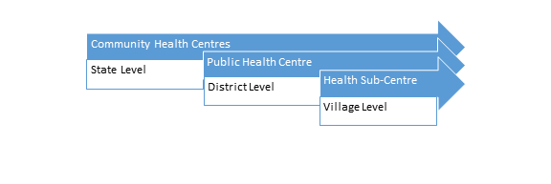
The health centre in Ragunathapuram was a sub-centre of the PHC (Public Health Centre) in Challur district (for Rajapet Mandal) and the workers included 4 ASHA (Accredited Social Health Activist), 1 ANM (Auxiliary Nurse Midwife), as well as 4 Anganwadi teachers. All the workers in the centre were women. The information was collected by the focused group discussion method. All the services offered in the centre were completely free of cost.
The qualifications included tenth basic education for all the workers as well as an additional two years of training for the ANM worker, 21 days recurring training for the ASHA workers and Anganwadi training for the teachers. For this particular PHC, this training occurred in Dilsukhnagar in Hyderabad.

Some important statistics that we gathered from the workers present were:
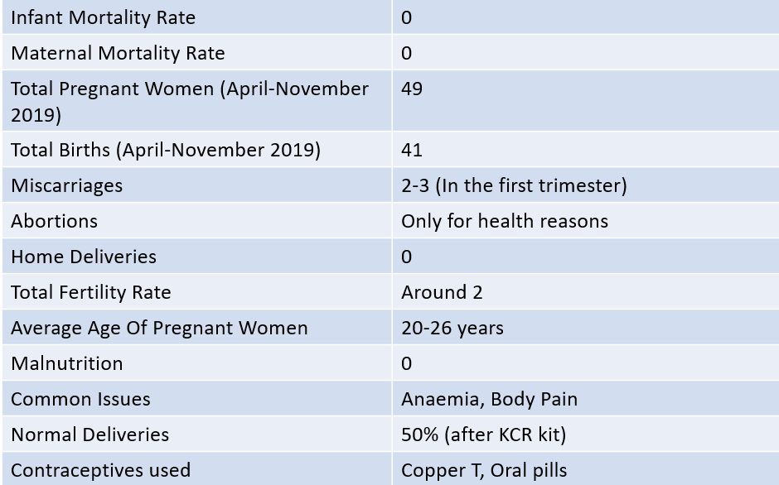
According to the workers present on site, the flagship programs for the effective and safe deliveries of women in the centre included the Amma Odi and KCR Kit scheme (where all expectant mothers were given financial assistance of Rs.12,000, plus an additional 1000 in case of a girl child, as well as a 16 item kit at the time of birth containing items such as baby clothes diapers etc) and the Aarogya Lakshmi scheme ( in which all pregnant women were given nutritional counselling to combat problems like anaemia). These schemes are used as a means to increase institutional deliveries and decrease malnutrition levels among mothers as well as infants. One interesting fact we came across was that since the introduction of the KCR Kit, normal deliveries had increased to 50%, and there were 0 home births in the village.

Apart from dealing with pregnant women, the centre also offered free medicines to the general population across the village for diseases such as cold, fever and TB. Additionally they also conducted regular surveys to facilitate the early detection of such illnesses, on which they could not use masks as the villagers saw that as a mark of superiority and followed the principle distance method.
Apart from this, a survey of newly married couples was also conducted periodically and information about contraceptives, birth control and family planning was provided to the couple to avoid unwanted pregnancies. In case such pregnancies did occur, separate counselling was given to both husband and wife, although the wife was generally ‘convinced’ to carry on with the pregnancy in the words of the workers.
Interestingly, we also found out that hysterectomies, or the removal of uterus, was quite common among older women (40-45), due to increased bleeding and body pain which prevented them from working in fields or weaving.
According to the workers, the major complaints that they had from their work was that their salaries were quite irregular and depended on the number of pregnancies and injections ( and averaged about Rs.7200/month), sleep deprivation since they were available on call 24/7, extreme proneness to infections because of the lack of masks and the like. However, the also said that they were still happy to do the job since it gave them a sense of community and satisfaction and increased their level of awareness.

Apart from ANM and ASHA workers, we also met with Anganwadi teachers who contributed to the sector by measuring and monitoring nutritional levels among the children in their care. To do this, they were provided with a nutritional booklet (as attached below), to measure the height and weight of every child each month. If the child fared on or above the green mark, the child had appropriate nutrition, yellow meant danger of malnutrition, and red meant that the child was malnutrition. According to the booklets present, no child in Raghunathapuram fell in the malnutritioned category.
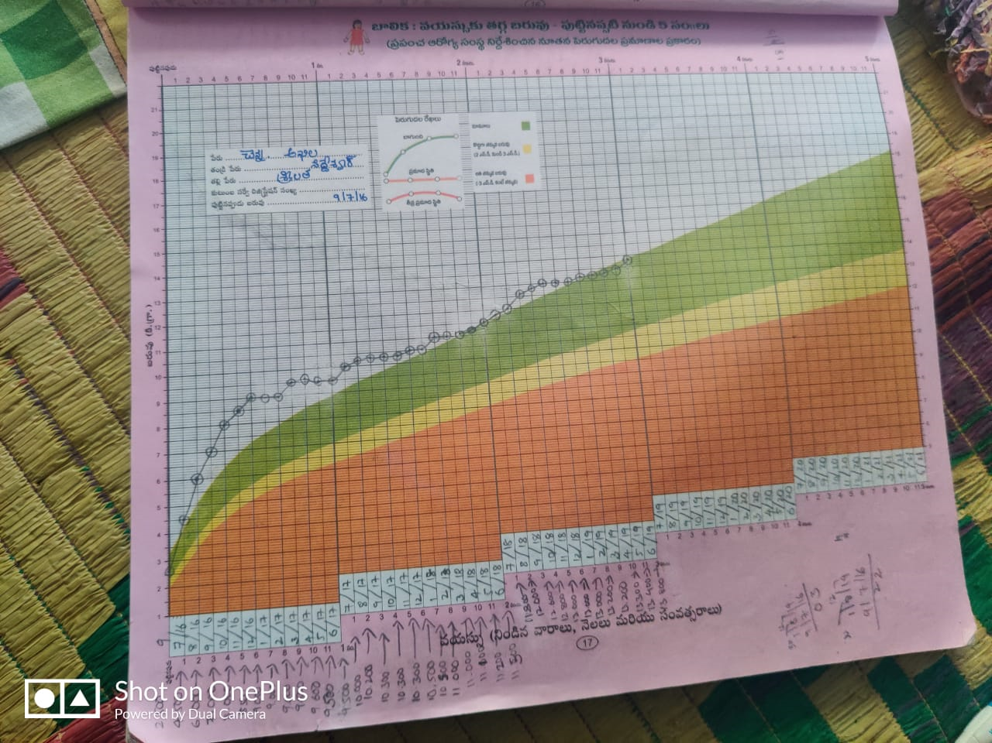
Fig (b) : Nutrition map of the children

Private Medical Practitioner (PMP):
While there were two Rural Medical Practitioners (RMPs) in the village, they were unavailable on both the days that we attempted to visit them. Hence, we visited the PMP of the village. The PMP, Dr. Sudarshan, has been practicing the profession since 1982, after completing a two year course in a government hospital for 2 years, twice a day. According to him, the most common medical problems in the village were:
- Women- body pain, anemia, arthritis
- Men- body pain, alcohol related diseases, lung diseases
- Children- cold, fever, pneumonia
Apart from this, dengue and malaria were also very prevalent in the village due to a high population of mosquitoes in the village.

One thing he pointed out was that most patients that visited him were poor, as the rich residents preferred to visit the private hospital in the neighboring village. As a result, he only managed to earn approximately Rs.10,000 a month.

WATER AND SANITATION:
The drinking water needs of the village were taken care of by the Any Time Water (ATW) scheme which provided for 60L of water per family in the village. For the working of this scheme, smart cards were issued to all the families which could be swiped twice a day in the tank located near the water filter (in the Padmashali Sangam Hall), to withdraw their daily quota of water.

For sanitation, 5 employees- 3 women and 2 men were employed. Their work included all sanitation needs of the gram panchayat, cleaning of drainage system and workplace of ASHA workers, cleanliness of roads. One quite astonishing thing that we found was that while the Gram Panchayat office claimed to pay the sanitation workers Rs.8500/month, according to the workers themselves, they were paid only Rs.2500/month and were given no incentives or bonuses. This income was supplemented only by the income of their husbands, daily wage labourers who earned 200-300 rupees a day depending on the work.
The workers also complained of the lack of dignity of their work and alleged that the villagers showed them no respect which is what they craved.

REFLECTIONS ON THE EXPERIENTIAL LEARNING:

At the offset, we thank our Telugu translators for being so cooperative and patient with all of us on the field, as in Raghunathapuram, majority of our respondents were Telugu speakers. Our group comprised of all Hindi speaking people, so we were initially worried about how we were going to proceed with our experiential learning, language being one of our major concerns. But, because of our Telugu translators, we were able to carry on our tasks effectively.

The four days we had spent on the field, interacting with villagers, trying through the best of our abilities to understand their lifestyle which was an eye opener for all of us. The pace with which rural areas are transforming was beyond our imagination. Before going on the field we had a certain picture about villages comprising bullock cart, kutcha road and kutcha houses, as well as a basic lack of amenities in our perception. But, now after having spent a few days among the villagers and in the village, our perceptions of what a village look likes, has changed significantly. The love and care that villagers had showered upon us was overwhelming. The ease with which they had accepted us and the eagerness they showed to share information about their lifestyle with strangers like us, was exhilarating. The ‘ WE’ feeling among the communities was noticeable feature. They attached great importance to their communities which was reflected in their residential pattern.

However, there was complete segregation of the communities. Caste based discrimination was evident in the village. The age old system of restricting to their caste based occupation again was prominent in the village. For Instance, in our interaction with the people of Rajaka caste, it was mentioned by them that they cannot afford to do the job of other caste, otherwise they will be monetarily penalised by their ‘Sangham’.

Another overwhelming experience was the level of awareness on education and healthcare that the people had in the village. For Instance, during our interaction with the students in the school and outside as well, especially girl students, had mentioned to us that they want sports infrastructure in their school premises,degree college in their village, clean toilets in their schools etc. This made us feel that Girls too in the village had dreams and ambitions, contrary to the popular image. It was emotional as well as concerning for all of us.

Awareness about cleanliness especially on menstrual hygiene among women was appreciable. Women to a large extent were using Sanitary pads. The activism that the ASHA and ANM workers have demonstrated in spreading awareness on the precautions to be taken during pregnancy, on family planning, administering vaccinations to children regularly, on the importance of nutrition for children and the female population reflected in the zero IMR and low MMR, has been instrumental in improving the health indicators of children and women and the village at large. However, a continuing worry has been a lack of a proper hospital in the village for which the residents have to travel at least 12kms to Aler, a neighbouring village.

One of the most striking features of the village was presence of 84 Self Help groups. When we heard the count, we could not believe it. The groups have been instrumental in sustaining their livelihoods. They take loans to help their family members and for their children’s education. However, only a few of them are running successfully.

Robust Infrastructure -- street lights, telecommunication,roads,water supply, toilets was another eye catching feature of the village. However, on our transect walk we discovered that some communities on the other side of the village, did not have street lights, pucca roads, water supply was also not regular and even transport facilities were not appropriate.

Another worrisome experience was the weak political representation of women. Even though they were elected to the seats,they were represented by their husbands in the meetings. Due to this, the issues concerning women were not extensively discussed in the meetings. The domination of males in taking final decisions for the family was the testimony to our patriarchal society.
However, on the brighter side , during our interactions with households , we found that women even though did not have final decision making power, but were allowed by their male counterparts to share information with us.
The social security system was robust in the village. Old people told us that they receive old age pension, which acts as a major financial support for them. However, beedi workers, who did not have PF account, which was highly common, were not paid pensions.

SUGGESTIONS:
- Health infrastructure-- especially hospital in the village, proper washrooms with adequate water supply.
- Educational infrastructure --Buses for college students,adequate classrooms and sports infrastructure
- Proper transport facilities for the people to commute easily and safely.
- Direct linkage of weavers with the market
- Robust irrigation system - proper implementation of Gandamall project (suggested by farmers themselves).
- Linking of various schemes like linking NREGA with farming wage labour ( suggested by the Sarpanch)

In conclusion, we can say that we had a great learning experience on the field. Officials as well as the people in the village were highly accommodative and were willing to provide information to us.
All this was possible because of Tata Institute of Social Sciences and Palle Srujana organisation, who provided us with the opportunity to interact with the villagers in person and to understand their perspective on development --- ‘WHAT VILLAGERS WANT?’- their livelihoods, economy, social structure, governance, health and educational aspects. The orientation lecture organized by Palle Srujana were immensely helpful during our field stay and helped us to have an effective and highly educational learning experience in the village.

